CPHAZ Symposium 2022
How do I join Zoom Events to access the CPHAZ Symposium?
You will NOT receive a Zoom link. You will have to join the Symposium using the steps outlined below.
Before you get started, do you have a Zoom Account created? REMEMBER YOU NEED A ZOOM ACCOUNT TO JOIN THE SYMPOSIUM!
- If you do not have a Zoom account associated with the email you used to register for the event, please create a free Zoom account prior to the Symposium by going to: https://zoom.us/signup
- If you have a Zoom account but it is associated with a different email address, please update us of your email address by emailing Julia Luca at cphaz@uoguelph.ca She will allocate a new ticket for you using this email address.
- If you already have a Zoom account associated with the email address you used to register, then you are good to go!
Step 1: You should have received an email from Zoom from the email address 'noreply-zoomevents@zoom.us'. This email should look like this (screenshot below).
If you did not receive this email, please let me know ASAP!
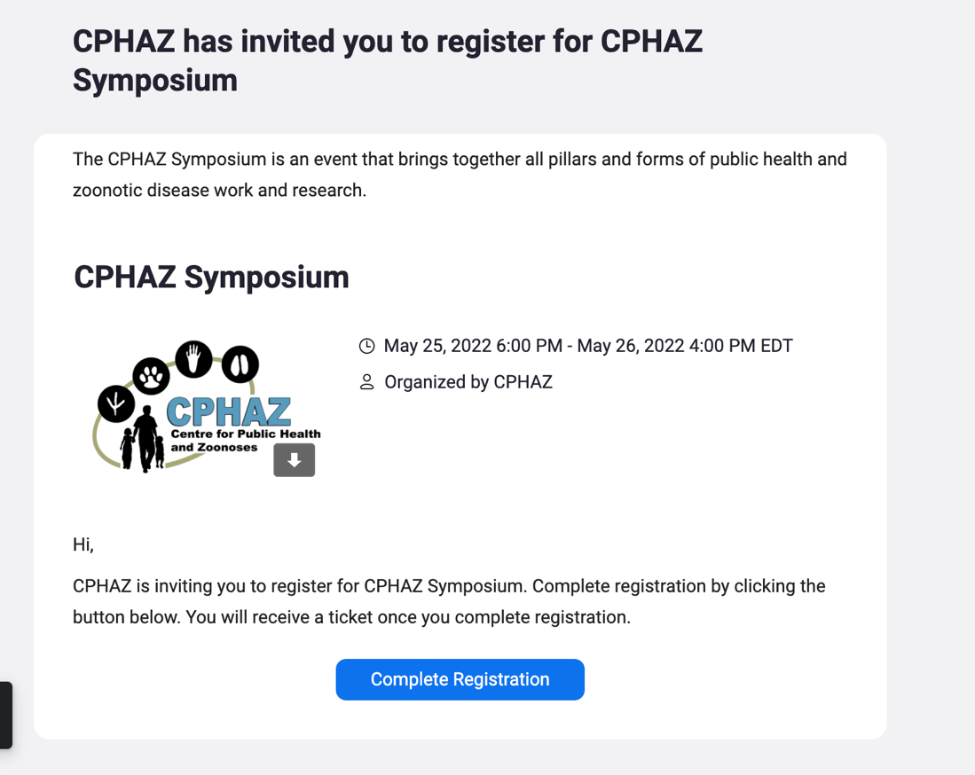

If you are a speaker or moderator your email will look slightly different (see below), but the steps are still the exact same.
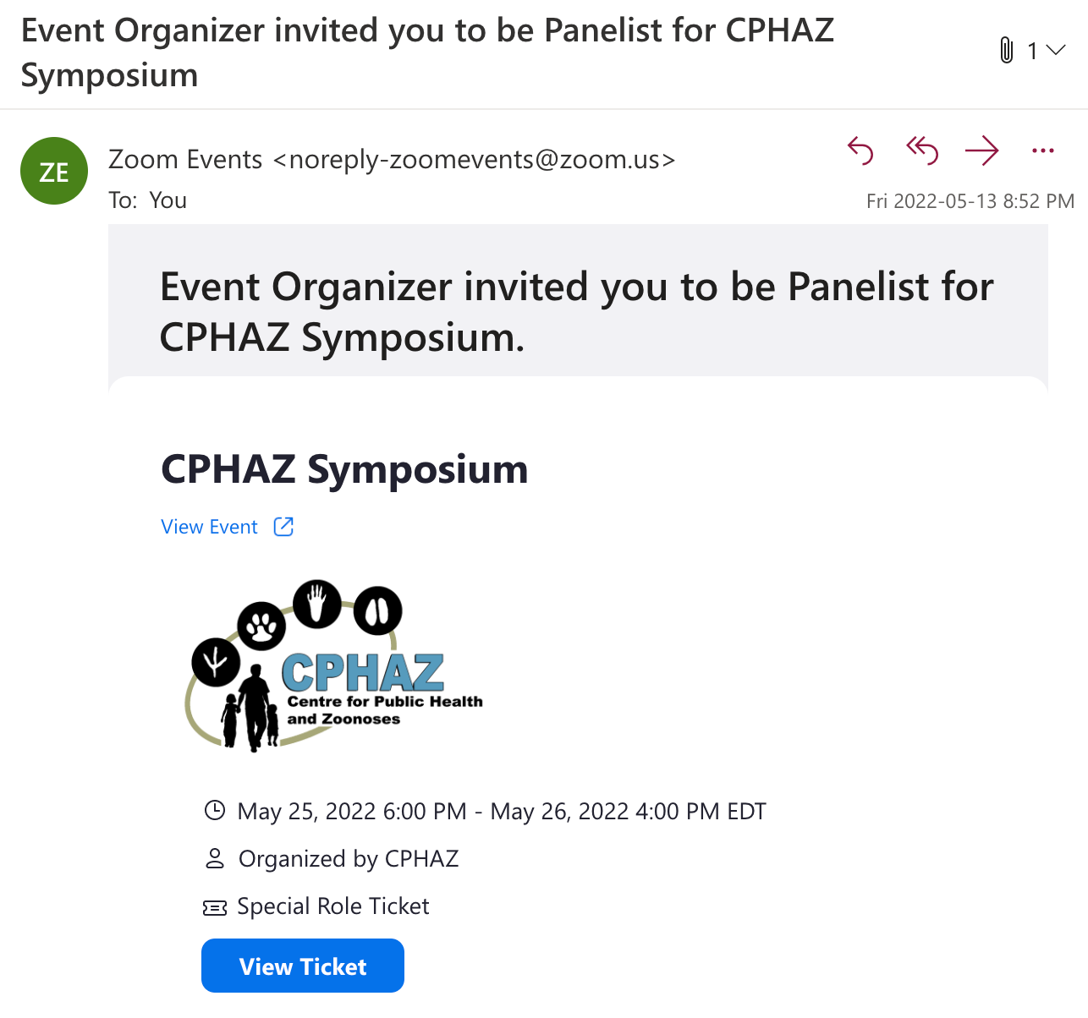
Step 2: Click on the blue “Complete Registration” button. This will prompt you to complete your registration by ensuring you have a Zoom account set up associated with your email address. This is where you would sign into your Zoom account.

Step 3: Once your registration is complete you will get an email that looks like this (screenshot below). You will then click on the blue “Join Lobby” button to enter the ongoing session.
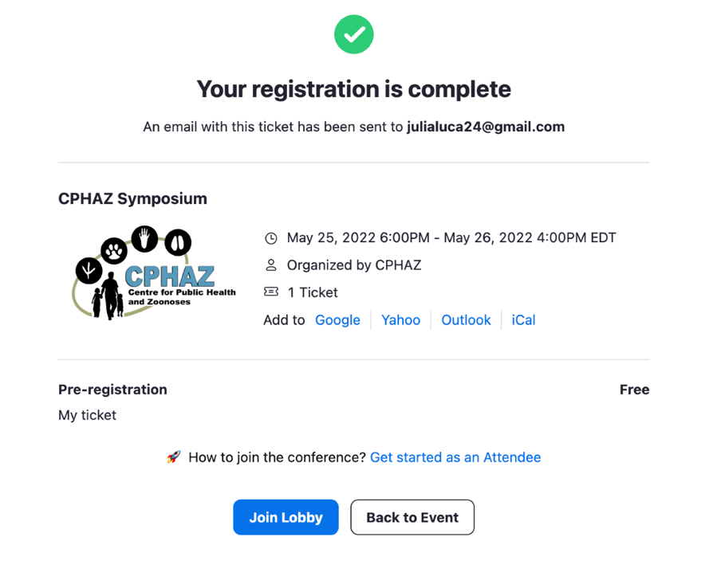
Step 4: If you have a Desktop version of Zoom you will get a pop-up that looks like this (screenshot below). This is NOT THE LOBBY! Please minimize this screen and go back to the browser (picture in step 5).
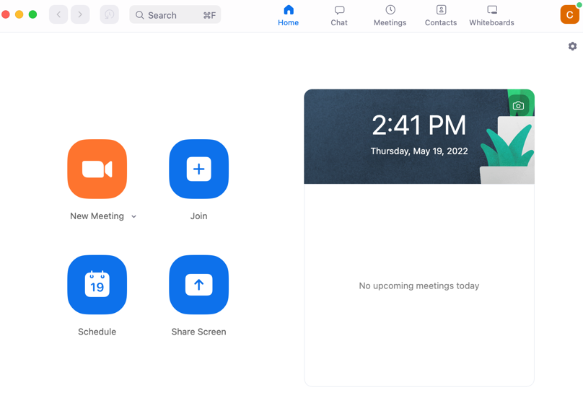

Step 5: Your browser will look like this (screenshot below). You can then click on the blue “Join Lobby” button or the “Skip and Join In-Progress Session” button.
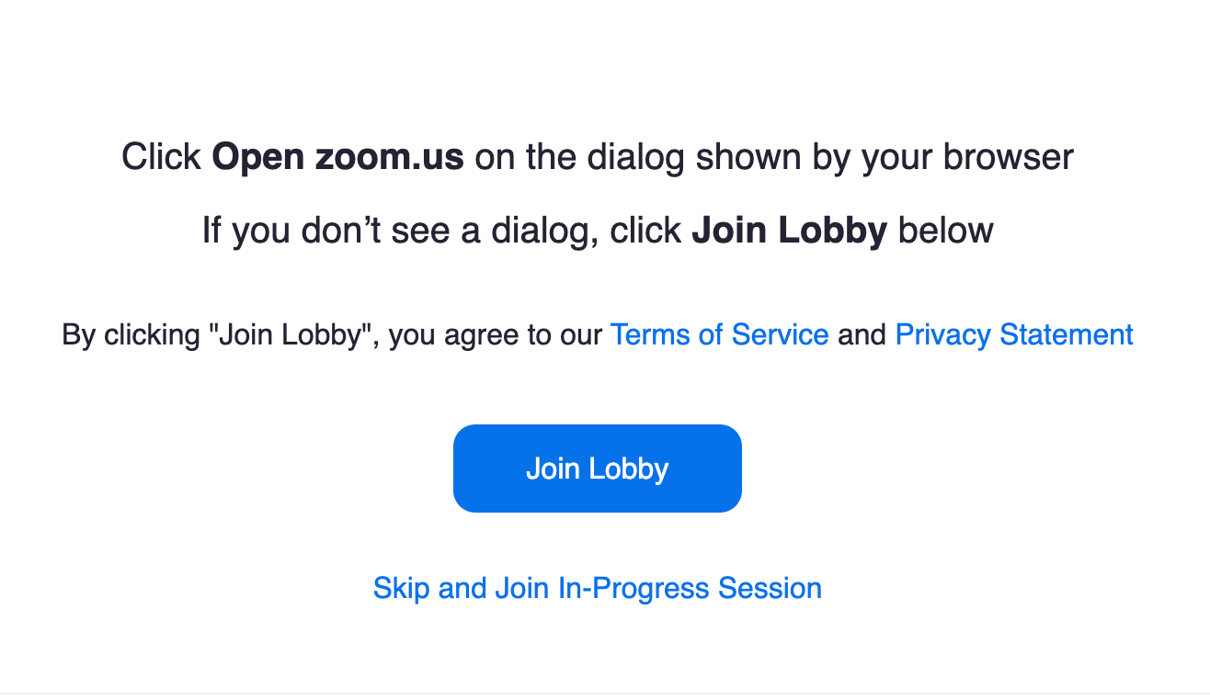
Step 6: You will know you are in the Lobby if it looks like this (screenshot below). At this point you can click on the “Sessions” button on the left-hand side and join the ongoing session.
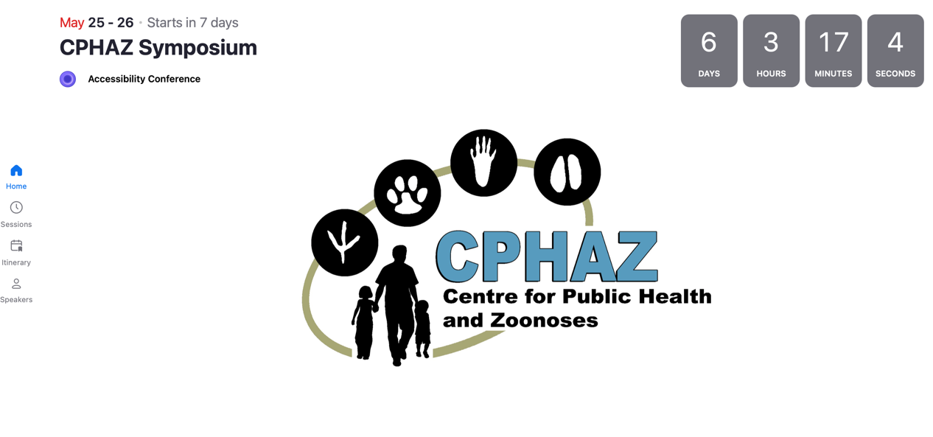

Possible Errors: What does it mean if I get this on my screen?
If you get an "Oops" pop-up when you try to complete your registration (see screenshot below), it means that the email address you used to register is not associated with a Zoom account. If this is the case, you will have to click the "Switch Account" button and register. You can also email me at cphaz@uoguelph.ca and switch the email account you have registered with.
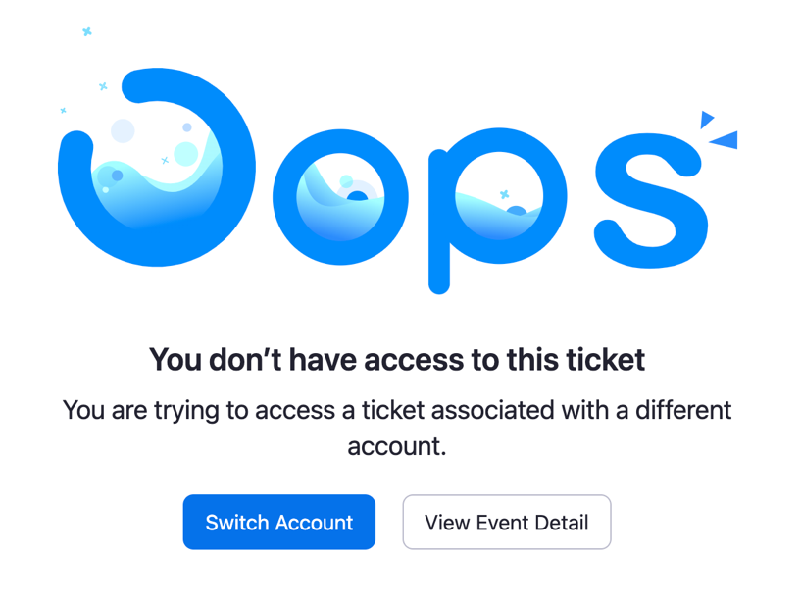
If you get a blank lobby page (screenshot below) it means that you do not have the latest version of Zoom. To update to the latest version please go to this link to check for Zoom updates: https://support.zoom.us/hc/en-us/articles/201362233-Upgrading-Zoom-to-the-latest-version

Other Commonly Asked Questions:
- Where can I find the Symposium program?
You can find the program for the Symposium on our CPHAZ website: www.cphaz.uoguelph.ca/cphaz-symposium-2022/
- The Symposium is a 2-day event on May 25-26. Do I need separate links to join either day?
No, you can join any session of the CPHAZ Symposium using the email you got from Zoom with the email address 'noreply-zoomevents@zoom.us'
- Can you just send me a Zoom link so that I can join the Symposium?
Unfortunately, we cannot send you a link for you to join the Symposium without you having to log into your Zoom account. This is a limitation of using the Zoom Events platform. We apologize for any inconvenience this may cause.
- Why do I need a Zoom account to join the Symposium?
This year we are using Zoom Events as the platform for our virtual Symposium. A limitation of this platform is that everyone who joins the conference, whether you are a speaker, moderator, or audience member, must have a Zoom account in order to retrieve their ticket or invitation. This means that the email you used to register has to have an associated Zoom account.
- Do I need a Zoom Basic or Pro account to join the Symposium?
You can have the free (basic) version of Zoom. You do not need to pay for the Pro Zoom account.

If you have any other questions, please contact Julia Luca, the CPHAZ Program Coordinator, at cphaz@uoguelph.ca

